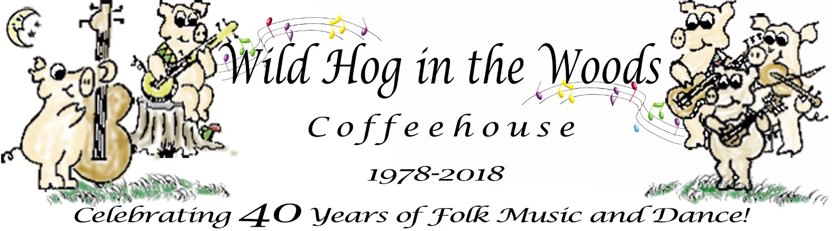
953 Jenifer Street, Madison, WI 53703 www.wildhoginthewoods.org

Wild Hog in the Woods Celebrates 40 years with Barn Dance in Olin Park, Saturday, July 21st

Contact: Jamie Diana Poindexter  Phone: (608) 850-9556  Email: jamiep@wildhoginthewoods.org | FOR IMMEDIATE RELEASE  July 10, 2018

- Wild Hog in the Woods Celebrates 40 years
- Potluck and Barn Dance at Olin Park
- Everyone who enjoys folk music and dance are welcome

Madison, Wisconsin - The Wild Hog in the Woods Coffeehouse is celebrating its 40th anniversary with a barn dance on Saturday, July 21st at Olin Park, Madison.

The Barn Dance will be held in the Olin Park Pavilion (Barn) starting with a potluck dinner at 5:00 PM, Saturday, July 21st. The Hog will provide eating utensils, plates and napkins. At 6 PM all will gather around our memorial tree in the park to remember past members and folk artists and to share our Hog memories. Dance starts at 7:00 PM.

Live music to dance by will be performed by members of local Old-Time dance bands: Lakeview Ramblers, Rattletrap, and Stone Soup. Calling will be by Roger Diggle and Mike Mossman. Admission to the dance is a suggested donation of $10. Souvenir t-shirts and mugs will be available for purchase.

“Who knew 40 years ago when we created the Wild Hog that it would still be providing a wide variety of folk music, singer/songwriters and dance,” said Jamie Poindexter, echoing the thoughts of several members.

Details are at www.wildhoginthewoods.org

PreSS KIT available:
This press release in PDF and DOCX and selection of photos, posters and more are available at:
wildhoginthewoods.org/Anniversaries/2018/PressKit/index.html
Upcoming special anniversary events include:
- Irish Singer/Songwriter Aoife Scott on stage September 7
- Outdoor Concert for Wil-Mar Neighborhood Association’s Volunteer Celebration, September 21
- Anniversary/Birthday Concert in the Round, November 30
- Folk concerts are Fridays at 7:30pm, September through May, 953 Jenifer Street, Madison.

About the Wild Hog in the Woods Coffeehouse:
The Wild Hog in the Woods first opened on November 30, 1978. In the spring of 1978, several folk musicians began talking about possible outlets for folk music beyond their living rooms and record players. They wondered about finding a location which would be permanent and open to the public, a place where folks could go to hear or play folk music even if they did not know anyone in town. There weren’t many venues with small open stages where they could perform.

Posters were hung on street kiosks and store fronts around town to find other interested people. The consensus at the early meetings was that a new space was needed, and it should be an informal 1960’s coffeehouse.

Later meetings led to our incorporation as a non-profit, non-stock organization and also to organize as a cooperative. With Madison’s strong cooperative community and with a healthy concern against ‘going in over our heads’ as a commercial venture, we determined that a cooperative would be the way to go, the safest economically, and the fairest socially.

“We really think cooperation is a good idea and we love to do it,” said Ben Doran, musician and volunteer.

“It’s been determined over and over again that a broad base of ideas and personal support is important for the operation and long life of the Wild Hog,” said Lisa Johnson, musician and volunteer.

Key points of interest about the Wild Hog:
- The Wild Hog in the Woods is a membership organization, a not for profit based on cooperative principles that was started by musicians in 1978 when there were not many venues at which to play their music.
- The Wild Hog operates a 60’s style coffeehouse with live folk music and other special events, workshops, dances, or in cooperation with other organizations.
- Members play an important role in the Wild Hog, volunteering their time to host the coffeehouse and other events, including promotion, booking performers, running sound, baking, newsletter and web site, and much more. We welcome new members!
- If you’re interested in performing at the coffeehouse, playing or calling at a barn dance, becoming a member, or would like to get involved with the Coffeehouse in any way, you can simply talk to the person at the admission table, contact us by email at info@wildhoginthewoods.org or visit our web site at www.wildhoginthewoods.org

-End-

